Jade Pearl
COSC 320-001 Lab 10: Graph Traversal 4/30/2023

Lab report: I authorize that what was done in this lab is my own work. I finished this lab in approximately 2 hours.

Pre-lab:
- Review materials learned for graph traversal
- Perform BFS and DFS for graph B
  - BFS: ABCDEF
  - DFS: ABCDFE

Files Created:
lab_09.cpp

Lab 10
Exercise 1: Read and understand “d_graph.h” and “d_util.h”, which may be used in the program
Exercise 2: Create a graph data file named “graphB.dat” for given graphB
Exercise 3: Write a program named lab_10.cpp that use the graph B. Program will prompt user to input a vertex, use input value to carry out a BFS and use writeContainer() to display the set of reachable vertices, and perform DFA on entire graph and use writeContainer() to display the list of vertices in the reverse order of their finishing times

Source Code:
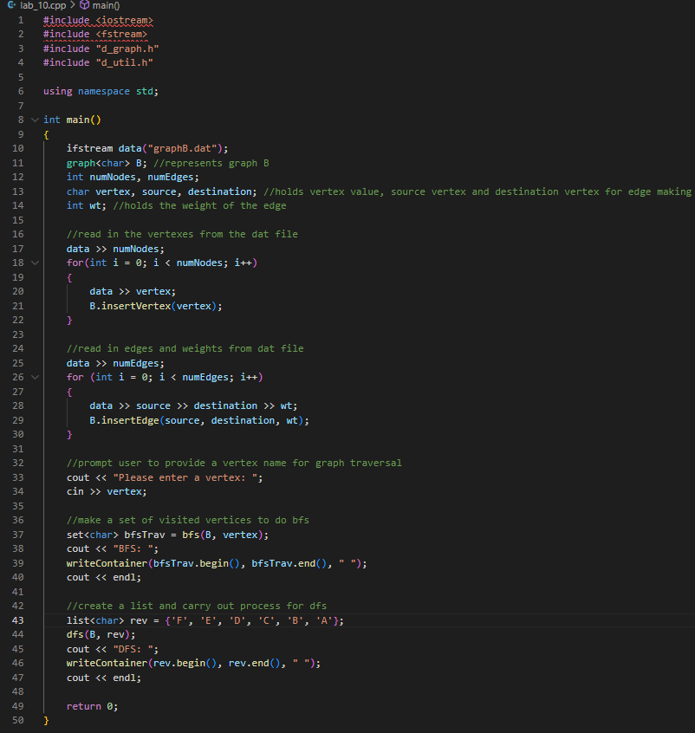
Sample Outputs:
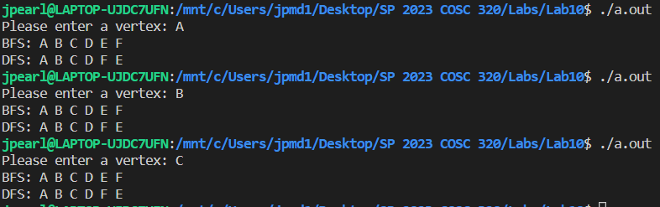
Note: Each vertex entered yields the same result

